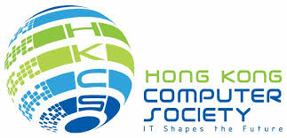
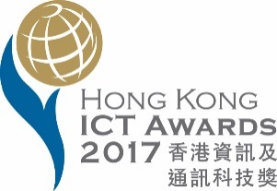
Prepared on March 31, 2017
For Immediate Release
Hong Kong ICT Awards 2017: Best Business Solution Award
Annual Ceremony honours 16 Outstanding Entries this year

Hong Kong – March 31, 2017 – The Hong Kong ICT Awards 2017 (HKICTA 2017) recognised 11 outstanding winning entries with 16 awards in the category of Best Business Solution Award at its successful conclusion today. As the host and lead organiser of the award for the past 11 consecutive years, the Hong Kong Computer Society (HKCS) has dedicated itself to appraising the many excellent entries with the highest professional standard.

Mr. Michael Leung, President of the Hong Kong Computer Society, said in his opening speech at the Award ceremony, “We are again honoured to be the lead organiser of the ‘Hong Kong ICT Awards 2017: Best Business Solution Award’ (HKICTA 2017) for this year. This annual Award provides an excellent opportunity for local companies to demonstrate their remarkable accomplishments, and serves as a platform to encourage original software developments and promote innovative applications of information technology, both in business and in the community. The success of this Award helps to raise public awareness of how rapidly ICT is changing the ways we live, work, play and learn.”

Mr. Leonard Chan, Chairman of the Organising Committee of ICT Awards 2017: Best Business Solutions Award, commented, “This is a locally espoused and internationally acclaimed brand of ICT awards, streamed into 3 categories, namely, ‘Best Business Solution (Application) Award’ , ‘Best Business Solution (Product & Service) Award’ and ‘Best Business Solution (e-Commerce) Award’, as well as a special award, the ‘Outstanding SME Award’, which, in its respective award stream, is given to recognise the most innovative application, product or service developed by an SME or specially targeted for use by SMEs. Each award undeniably showcases our efforts in promoting ICT development in Hong Kong in respect of the deployment of innovative applications, the quality of products and services, and the needs of business and the community.”
This year, GoAnimate Hong Kong Ltd., with its GoAnimate: Cloud-based animated video, is the Grand Winner as well as the Gold prize winner of the “Best Business Solution (Product & Service) Award” chosen from among 13 enterprises. The cloud-based GoAnimate is the quickest, simplest and most cost-effective solution for producing and sharing a professional-looking video. Built-in easy-to-use tools and unlimited subscription features are ready for use without constraints; all users need is a stable Internet connection for access to the cloud.

“We are extremely honoured to receive this prestigious award, and we are delighted that our love of innovating through design has been recognised by the ICT industry,” said Mr. Alvin Hung, Founder and CEO of GoAnimate. “Everyone knows that Hong Kong harbours a real wealth of innovation, particularly in engineering and design. At GoAnimate, we train passionate professionals to be world-class design oriented innovators. With our 'Live in Hong Kong, Experience Silicon Valley' corporate culture, our team will continue to create world-class solutions that lead the world in DIY animation – helping businesses, schools and individuals around the world to have fun, thrive and communicate effectively.”

The Gold prize for the “Best Business Solution (Application) Award” went to the Electronic Health Record Sharing System (eHRSS) developed by the Electronic Health Record Office of Food and Health Bureau, The Government of the Hong Kong Special Administrative Region / Hospital Authority. “We are honoured to have this prestigious award and grateful for the recognition we have received,” said Ms. Ida LEE, Head (Electronic Health Record), Electronic Health Record Office of the Food and Health Bureau. “The territory-wide Electronic Health Record Sharing System (eHRSS) was launched on 13 March 2016, introducing multi-way sharing of individual patients’ health data between public and private healthcare providers, subject to patient's consent. The eHRSS will enhance continuity of care as well as facilitate better integration of different healthcare services for the benefit of people in Hong Kong. It also provides the infrastructure to support the healthcare reform and the development of new healthcare service models such as public‐private partnership. The eHRSS promulgates open standards and uses structured data for sharing, thus enabling healthcare professionals to make better clinical judgements and facilitating development of ICT solutions for the health sector.”

In hosting this annual flagship award during over many years, a growing list of remarkable accomplishments of local ICT enterprises have been witnessed and acknowledged. HKCS will continue to encourage local entrepreneurs and IT professionals, fostering insightful vision and business acumen to further extend their contributions to the development and application of innovative technology, in order to improve Hong Kong’s overall competitiveness and boost operating efficiency through enhancing product and service quality in different industries.

For a full list of winners of the HKICT Awards 2017: Best Business Solution Award, please refer to the accompanying Appendix.

About the Hong Kong ICT Awards: Best Business Solution Award
The Hong Kong ICT Awards were established in 2006 with the collaborative efforts of industry, academia and the Government. Steered by the Office of the Government Chief Information Officer, and organised by Hong Kong ICT industry associations and professional bodies, the Awards aim to build and maintain a locally espoused and internationally acclaimed brand of ICT awards.

The “Hong Kong ICT Awards: Best Business Solution Award” (formerly known as “IT Excellence Awards”), was established in 1998 by the Hong Kong Computer Society, and has become a well recognised award in Hong Kong. This annual event has become a great tool to encourage the use of ICT, to stimulate innovation and competitiveness in the ICT industry and to raise public awareness of ICT application development.

About the Hong Kong Computer Society
Founded in 1970, the Hong Kong Computer Society (HKCS) is a recognised non-profit organisation focused on developing Hong Kong's Information Technology (IT) profession and industry. Members hail from a broad spectrum of Hong Kong's IT community, ranging from corporations to like-minded individuals, all coming together to raise the profile and standards of the profession and industry. As a well-established IT professional body, the Society is committed to professional and industry development as well as community services, that ensure the IT sector continues to make a positive impact on peoples' lives with three main goals, namely, 1) talent cultivation and professional development, 2) industry development and collaboration, and 3) the effective use of IT in our community.
For more information, please visit http://www.hkcs.org.hk.
– End –
For media enquiries, please contact:
iPR Ogilvy & Mather
Benny Chan / Christina Chan / Roy Tang
Tel: | 3920 7663 / 3920 7674 / 3920 7665
Fax: | 3170 6606
Email: | benny.chan@iprogilvy.com / christina.chan@iprogilvy.com / roy.tang@iprogilvy.com

Hong Kong Computer Society
Coco Wong
Tel: 2834 2228
Email: cocowong@hkcs.org.hk

Appendix: 16 Outstanding Entries Hong Kong ICT Awards 2017: Best Business Solution Award
Award | Name of Applicant | Title of Entry
Grand | GoAnimate Hong Kong Ltd. | GoAnimate: Cloud-based animated video
Application
Gold | Electronic Health Record Office of Food and Health Bureau, The Government of the Hong Kong Special Administrative Region / Hospital Authority | Electronic Health Record Sharing System (eHRSS)
Silver | Hysan Development Company Ltd. / Cherrypicks Ltd. | Lee Gardens mobile app
Bronze | Hong Kong Applied Science and Technology Research Institute (ASTRI) | ASTRI Automatic Meter Reading System
Merit | Studio-R Co., Ltd. | HOMEY
Outstanding SME | Studio-R Co., Ltd. | HOMEY
Product & Service
Gold | GoAnimate Hong Kong Ltd. | GoAnimate: Cloud-based animated video
Silver | Everyware Ltd. | Caterlord Restaurant POS
Bronze | OneAsia Network Ltd. | OneAsia Smart Cloud – Manage Cloud Solutions
Merit | Sanyo Extended System Services Ltd. | ChainStorePlus – Enterprise Retail  Management Software for Global Retailers
Outstanding SME | Everyware Ltd. | Caterlord Restaurant POS
e-Commerce
Gold | Nil | Nil
Silver | Ubeing Mobility Ltd. | Posify – Omni-Channel Retail Management Cloud Platform
Bronze | iSTYLEUP Ltd. | iSTYLEUP – Global Fashion
Bronze | Ledo Media Technology Company Ltd. | Ledo Ads - O2O platform for enterprises to search and rent offline advertisement spots
Merit | Nil | Nil
Outstanding SME | Ledo Media Technology Company Ltd. | Ledo Ads
Outstanding SME | Ubeing Mobility Ltd. | Posify – Omni-Channel Retail Management Cloud Platform

Photo Caption:

Photo 1:
Speaking at the opening ceremony of the Hong Kong ICT Awards 2017: Best Business Solution Award, Mr. Michael Leung, President of the Hong Kong Computer Society, said, “Hong Kong Computer Society is again honoured to be the lead organiser of the ‘Hong Kong ICT Awards 2017: Best Business Solution Award’ (HKICTA 2017) for this year. The award serves as a platform to encourage original software developments and promote innovative applications of information technology, both in business and in the community. The success of this Award helps to raise public awareness of how rapidly ICT is changing the ways we live, work, play and learn.”
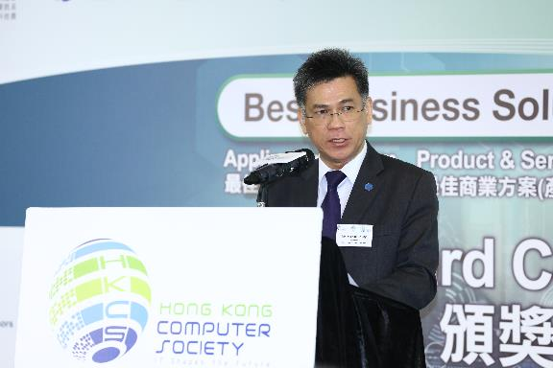

Photo 2:
Mr. Leonard Chan, Chairman of the Organising Committee of ICT Awards 2017: Best Business Solutions Award said that, “the Hong Kong ICT Awards 2017: Best Business Solution Award is a locally espoused and internationally acclaimed brand of ICT awards, streamed into 3 categories, namely, ‘Best Business Solution (Application) Award’ , ‘Best Business Solution (Product & Service) Award’ and ‘Best Business Solution (e-Commerce) Award’, as well as a special award, the ‘Outstanding SME Award’ at the opening speech.”
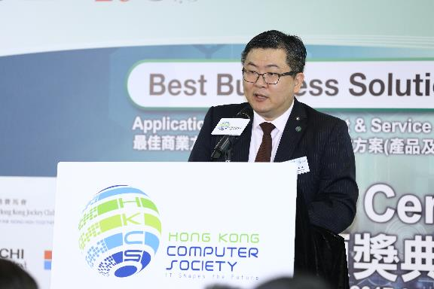

Photo 3:
Ubeing Mobility Ltd.’s Posify – Omni-Channel Retail Management Cloud Platform is the Silver prize winner of “Best Business Solution (e-Commerce) Award” as well as the winner of Outstanding SME.
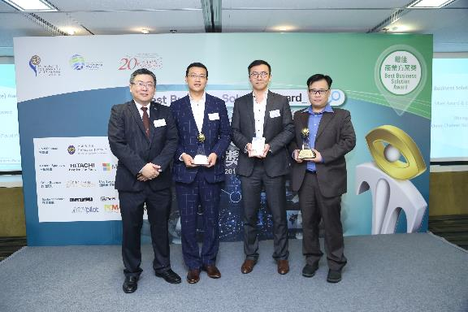
Photo 4:
Promulgating open standards and uses structured data for sharing, enables healthcare professionals to make better clinical judgements and facilitating development of ICT solutions for the health sector. The Gold prize for the “Best Business Solution (Application) Award” went to the Electronic Health Record Sharing System (eHRSS) developed by the Electronic Health Record Office of Food and Health Bureau, The Government of the Hong Kong Special Administrative Region / Hospital Authority.
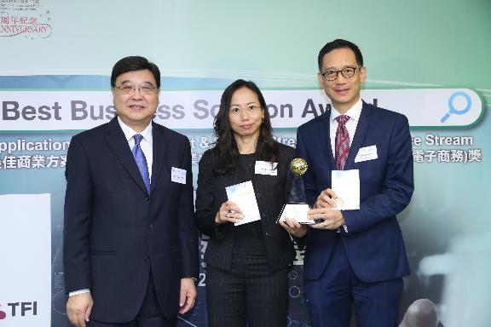
Photo 5:
GoAnimate Hong Kong Ltd. with its GoAnimate: Cloud-based animated video, is the Grand Winner as well as the Gold prize winner of the “Best Business Solution (Product & Service) Award” chosen from among 13 enterprises.
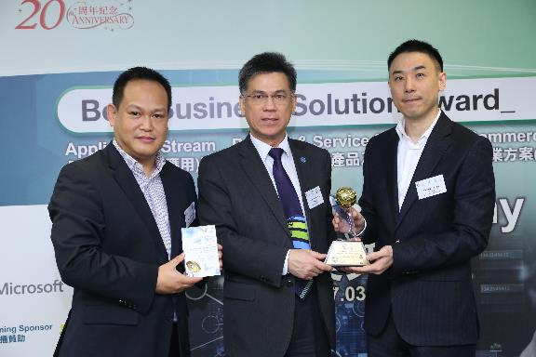
Photo 6:
Prof. Yuk-shan Wong, Chairperson, Judging Panel of Hong Kong ICT Awards 2017 – Best Business Solutions Award and the President of the Open University of Hong Kong said that the judges are impressed by all good quality and high standard entries when receiving a souvenir.
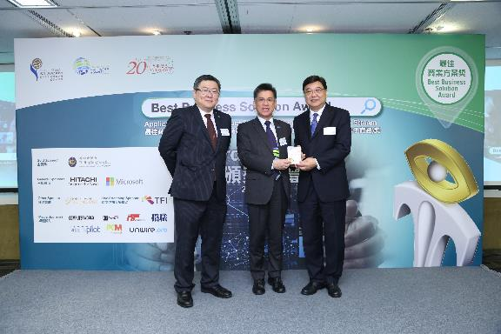
Photo 7:
All the winners and judging panel who participated in the Hong Kong ICT Awards 2017: Best Business Solution Award celebrated their achievements together and congratulated each other at the award presentation ceremony.
