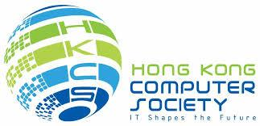

For Immediate Release
Celebrating 40 Years of Innovation
Hong Kong Computer Society Announces its Support towards Helping HK Enterprises Capitalise on the Belt and Road Initiative through Digital Innovation at its Hong Kong International Computer Conference 2017

Hong Kong, November 2, 2017 – Organised by the Hong Kong Computer Society (HKCS), the Hong Kong International Computer Conference 2017 (HKICC 2017) was officially kicked off today with an opening ceremony at the Hong Kong Convention and Exhibition Centre. Themed “Capitalise on the Belt and Road Initiative through Digital Innovation”, the conference gathered industry experts to discuss the emerging business opportunities generated from the Belt and Road Initiative, and consider how IT can help Hong Kong overcome the challenges brought by a decreasing local labour force and keep up with the pace of development.
The Hong Kong International Computer Conference marks its 40th anniversary in 2017. The Hong Kong Computer Society was honoured to have Professor Tieniu Tan, Vice Minister of the Liaison Office of the Central People's Government, HKSAR, Mr. Nicholas Yang Wei-hsiung, JP, Secretary for Innovation and Technology, HKSAR Government, and Mr. Bernard Charnwut Chan, President, Asia Financial Holdings and Asia Insurance, as honourable speakers at the opening ceremony of the 40th Conference. The Conference has brought together more than 500 participants from around the world.

Professor Tieniu Tan, Vice Minister of the Liaison Office of the Central People's Government, HKSAR, discussed the roadmap of AI development in Hong Kong and the Mainland, and Mr. Bernard Charnwut Chan, President, Asia Financial Holdings and Asia Insurance, reviewed the emerging business opportunities generated from the Belt and Road Initiative and Hong Kong’s innovation and technology advantages which can bring benefits to the Belt and Road Initiative.
“Belt and Road should pave the way for a new stage of overall economic and social development in much of Asia. The greater connectivity will enable major increases in flows of trade and investment, and of people and information. Potentially, this would be a continuation of globalization into regions that had previously been at least partly left out.” said Mr. Chan.

Ir Ted Suen, President of HKCS, said in his welcome speech, “IT plays a key role in our daily lives as it is an integral part of all aspects of contemporary society. As the HKICC steps into its 40th year, we will continue to collaborate with the HKSAR Government, local industries, academics and the community to discuss and capture each opportunity. Leveraging on the Belt and Road Initiative, we have to work together to develop more opportunities for the IT industry. Looking forward, we will continue to fulfill the role of a ‘super connector’, gathering experts from the local IT industry, and working towards a better Hong Kong.”
Seizing “Belt and Road" Opportunities with Smart City Measures
The Hong Kong Government has been investing more and more resources into developing Hong Kong into a smart city through innovation and technology, to improve the living standards of Hong Kong people. This brings a lot of business opportunities. Smart City and IoT are key technologies to enabling innovation, from creation and design to production and implementation of new products and services, which can help Hong Kong achieve high digital and financial performance.
Delegates were provided with the latest industry insights on how to harness innovation and technology to drive the real benefits to business.
Nurturing Competent IT Leaders with Professional Training
Furthermore, as a leading organisation in the local Information Technology (IT) profession and industry, the Hong Kong Computer Society has always been committed to, and focused on, the cultivation of IT talent. HKCS welcomes the tax relief measures that were announced in the recent Policy Address. It is proposed that the first $2 million of eligible research and development (R&D) expenditure will enjoy a 300% tax deduction with the remainder at 200%, to encourage investment in R&D from start-up enterprises and SMEs with limited capital, in addition to investments in market development and product development, enhancing the importance of IT talent to enterprises.
The Hong Kong Computer Society has also been working with tertiary institutions to promote IT education and training programmes. IT Careers Expo is organised annually to introduce over 500 IT-related positions and attracts over 1,200 attendees. HKCS also organises the IT Summer Camp with Shanghai Computer Society and Information Management Association, to excite and inspire the young minds of students from the Mainland, Taiwan and Hong Kong, on technology and innovation. In March of this year, HKCS launched the IT LEadership Accelerator Platform (iLEAP) for IT professionals. Members of the iLEAP Executive Committee come from different organisations and industries. A variety of activities, such as case studies, exchanges and visits will be held for IT managers to break through the bottleneck of business development and bring their businesses to a higher level in the digital era.

However, the current expenditure on R&D investment in Hong Kong is only 0.73% of the gross national product. The recent Policy Address announcement suggests a substantial R&D increase to 1.5% of the gross national product in five years, but this still falls behind other nations which are considered technology savvy, e.g. South Korea, the US and Finland, where their Gross Domestic Expenditure on R&D as a percentage of the Gross Domestic Product ranges from 2% to 4%. At present, most of the research talent in Hong Kong comes from the Mainland and foreign countries. The Hong Kong Computer Society will continue to work with the Government to train and pool together more technology talent, promoting progressive development.
This year’s two-day conference comprised multiple keynote sessions, presentations and panel discussions from high-profile speakers, each presenting different topics on opportunities from the Belt and Road Initiative. The Hong Kong International Computer Conference 2017 marks a milestone for the development of the ICT industry.

About the Hong Kong International Computer Conference (HKICC)
The Hong Kong International Computer Conference (HKICC) has been organised by the Hong Kong Computer Society (HKCS) since 1978 to provide an open platform for IT professionals in Hong Kong and the region to present their research papers and to share their experience. This annual flagship event is one of the best and most popular ICT conferences in Hong Kong. Nearly 500 delegates attended the conference last year, representing a variety of local and overseas participants from public and private sector organisations, including renowned ICT professionals, academics, executives and senior government officers.
For more details about the event, please visit http://hkicc.hkcs.org.hk/

About the Hong Kong Computer Society
Founded in 1970, the Hong Kong Computer Society (HKCS) is a recognised non-profit organisation focused on developing Hong Kong's Information Technology (IT) profession and industry. Members hail from a broad spectrum of Hong Kong's IT community, ranging from corporations to like-minded individuals, all coming together to raise the profile and standards of the profession and industry. As a well-established IT professional body, the Society is committed to professional and industry development as well as community services that ensure the IT sector continues to make a positive impact on peoples' lives with three main goals, namely, 1) talent cultivation and professional development, 2) industry development and collaboration, and 3) the effective use of IT in our community.

For more information, please visit http://www.hkcs.org.hk.

– End –

For media enquiries, please contact:

iPR Ogilvy & Mather
Jonathan Tam / Hidy Ip / Roy Tang
Tel: | 3920 7674 /3920 7609 / 3920 7665
Fax: | 3170 6606
Email: | jonathan.tam@iprogilvy.com / hidy.ip@iprogilvy.com / roy.tang@iprogilvy.com

Hong Kong Computer Society

Coco Wong
Tel: | 2834 2228
Email: | cocowong@hkcs.org.hk

Photo Caption:
Photo 1:
Mr. Nicholas Yang Wei-hsiung, JP, Secretary for Innovation and Technology, HKSAR Government, speaking at the opening ceremony of Hong Kong International Computer Conference 2017.
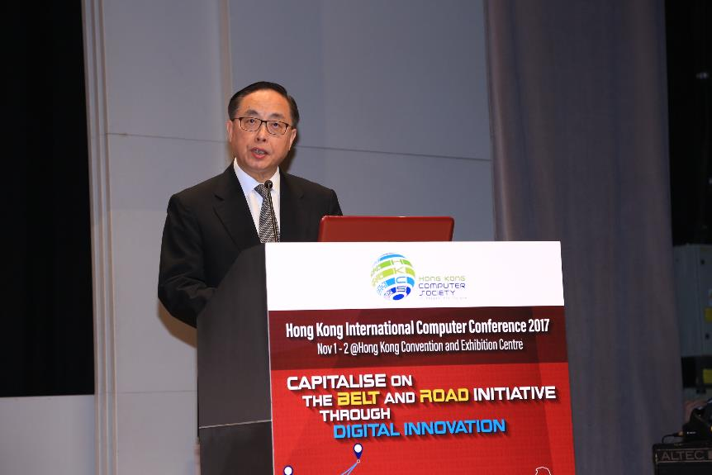

Photo 2:
In his opening speech, Ir Ted Suen, President of the Hong Kong Computer Society, said that HKCS will continue to fulfill the role of a ‘super connector’, under the topic of Belt and Road initiative, gathering experts from the local IT industry, and working towards a better Hong Kong.
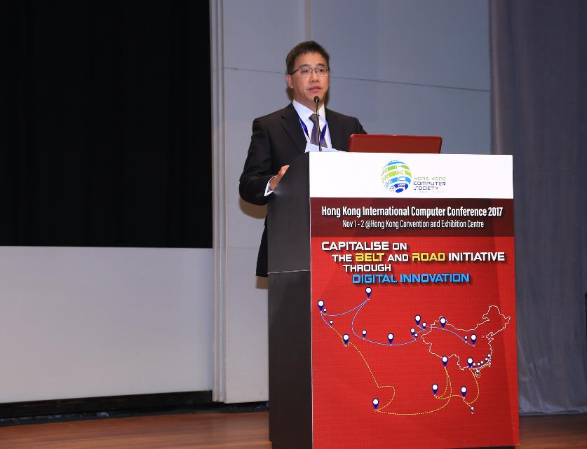

Photo 3:
Professor Tieniu Tan, Vice Minister of the Liaison Office of the Central People's Government, HKSAR (Second from right), Mr. Nicholas Yang Wei-hsiung, JP, Secretary for Innovation and Technology, HKSAR Government (Second from left), Ir Ted Suen, President of HKCS (Third from left), Mr. Andy Bien, Vice President (External Engagement) of HKCS and Chairperson of HKICC 2017 Conference Committee (First from right) and Dr. Gabriel Leung, Vice President (Branding & Communications) of HKCS and Chairperson of HKICC 2017 Programme Committee (First from left), officiated at the opening ceremony of the Hong Kong International Computer Conference 2017.
