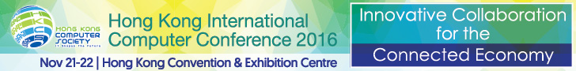
For Immediate Release

Hong Kong Computer Society Survey Reveals Local Business Opportunities Presented by the ‘Connected Economy’

97% of Hong Kong Business actively capitalize on opportunities presented by the ‘Connected Economy’

Hong Kong, 21 November 2016 – Hong Kong Computer Society (HKCS) today released a survey entitled “Opportunities and Impacts in the Era of the ‘Connected Economy’ and Smart City” during the Hong Kong International Computer Conference 2016. With an aim of understanding the views of professionals from ICT and other industries, across different career levels and age groups, about the huge business opportunities that the hyper-connected world can provide, 100 individuals were interviewed. Most of the interviewees felt strongly that the ‘Connected Economy’ has brought enormous benefits to their business.
Key findings of the “Opportunities and Impacts in the Era of the ‘Connected Economy’ and Smart City” survey were:
- 97% reported that their organisations actively excavate opportunities presented by the ‘Connected Economy’.
- 96% agreed that the ‘Connected Economy’ has provided a better business environment for their organisations.
- 59% recognised that the ‘Connected Economy’ benefits their organisations by providing more competitive services / products. [See Appendix 1]
- Despite the advantage of ‘Connected Economy’, as generally agreed by the interviewees, 70% thought that the ‘Connected Economy’ is not yet mature, 49% regarded it as being in the development stage, and 21% thought it is still in the initial stage. [See Appendix 2]

“Although more than two-thirds of interviewees agreed that the ‘Connected Economy’ is still at an early stage of its development in Hong Kong, they believe that it is a good way for them to actively explore and capitalise on business opportunities,” said Dr. NT Cheung, Chairperson of the Hong Kong International Computer Conference 2016 Organising Committee. “Furthermore, we also noted that the top catalysts named by interviewees for driving the future development of a ‘Connected Economy’ are the advancement of innovation and technology (92%), cross-industry cooperation (82%), talent nurturing (80%) and government policies (78%). In this light, I believe the collaborative effort of government, academia, industry and ICT professionals will continue to cultivate a ‘Connected Economy’ and, as a result, this concept will be pivotal to our quest for capitalising benefits to business, and Hong Kong as a whole. [See Appendix 3]

Mr. Michael Leung, President of the Hong Kong Computer Society, said, “The survey results announced today have clearly shown that the ‘Connected Economy’ is now making an impression on professionals across different industries, and we can see that this trend will definitely be an integral part in our daily lives, better equipping all of us in pursuing future development in ICT and innovation.”

About the Hong Kong International Computer Conference (HKICC)
The Hong Kong International Computer Conference (HKICC) has been organised by the Hong Kong Computer Society (HKCS) since 1978 to provide an open platform for IT professionals in Hong Kong and the region to present their research papers and to share their experience. This annual flagship event is one of the best and most popular ICT conferences in Hong Kong. Nearly 500 delegates attended the conference last year, representing a variety of local and overseas participants from public and private sector organisations, including renowned ICT professionals, academics, executives and senior government officers.
For more details about the event, please visit http://hkicc.hkcs.org.hk/.

About the Hong Kong Computer Society
Founded in 1970, Hong Kong Computer Society (HKCS) is a recognised non-profit organisation focused on developing Hong Kong's Information Technology (IT) profession and industry. Members hail from a broad spectrum of Hong Kong's IT community, from corporations to like-minded individuals, all coming together to raise the profile and standards of the profession and industry. As a well-established IT professional body, the Society is committed to professional and industry development as well as community services that ensure the IT sector continues to make a positive impact on peoples' lives with three main goals, namely, 1) talent cultivation and professional development, 2) industry development and collaboration, and 3) the effective use of IT in our community.
For more information, please visit http://www.hkcs.org.hk.

– End –
For media enquiries, please contact:
iPR Ogilvy & Mather
Benny Chan / Christina Chan / Roy Tang
Tel: | 3920 7663 / 3920 7674 / 3920 7665
Fax: | 3170 6606
Email: | benny.chan@iprogilvy.com / christina.chan@iprogilvy.com / roy.tang@iprogilvy.com

Hong Kong Computer Society
Coco Wong
Tel: (852) 2834 2228
Email: cocowong@hkcs.org.hk

Appendices: Opportunities and Impacts in the Era of the ‘Connected Economy’ and Smart City
Appendix 1
Question: Will your organisation try to learn more about the idea of the ‘Connected Economy’ and explore the opportunities that it may bring?
 | Number | Percentage
Yes | 97 | 97%
No | 3 | 3%
Total | 100 | 100%

Question: Do you agree that the ‘Connected Economy’ has provided a better business environment for your organisation?
 | Number | Percentage
Agree | 96 | 96%
Disagree | 4 | 4%
Total | 100 | 100%

Question: What benefit(s) do you think the ‘Connected Economy’ can bring to your organisation? (Multiple answers)
 | Number | Percentage in total
Provide more competitive services/products | 59 | 59%
Increase opportunities and income | 49 | 49%
Promote collaboration between teams | 49 | 49%
Increase productivity | 45 | 45%
Provide better quality services/products | 40 | 40%
Total | 242 | N/A

Appendix 2

Question: In your opinion, Hong Kong's ’Connected Economy’ situation is:

 | Number | Percentage
Beginning | 21 | 21%
Developing | 49 | 49%
Gradually improving | 29 | 29%
Well developed | 1 | 1%
Total | 100 | 100%

Appendix 3
Question: Which factors do you think are important for promoting the future development of a ‘Connected Economy’?

 | Important | Not important | Total
The application of innovation and technology (such as networking, big data) | 92% | 8% | 100%
Cross-industry cooperation | 82% | 18% | 100%
Talent cultivation | 80% | 20% | 100%
Government policies | 78% | 22% | 100%
Cross-regional and international cooperation | 65% | 35% | 100%
Economic climate | 64% | 36% | 100%

***
Photo Caption:

Photo 1:

Mr. Michael Leung, President of the Hong Kong Computer Society, said that the survey entitled “Opportunities and Impacts in the Era of the ‘Connected Economy’ and Smart City” was conducted to provide a better understanding of the opportunities brought by the ‘Connected Economy’ to Hong Kong.


Photo 2:
Dr. NT Cheung, Chairperson of the Hong Kong International Computer Conference 2016 Organising Committee, analysed the survey findings and pointed out that collaboration between government, academia, industry and talented IT professionals is the key to drive the development of the ‘Connected Economy’.
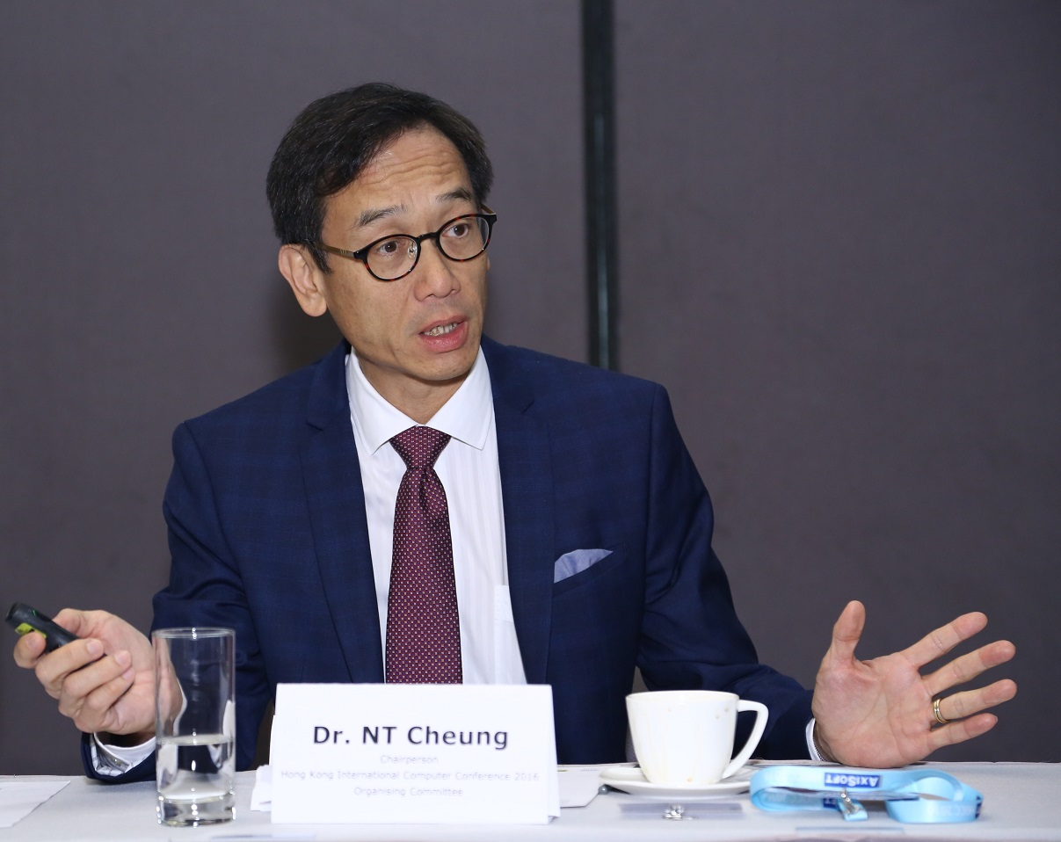

Photo 3:
Mr. Michael Leung, President of the Hong Kong Computer Society (2nd right), Dr. NT Cheung, Chairperson of the Hong Kong International Computer Conference 2016 Organising Committee (2nd left), and Mr. Matthew Chan, Vice President (Branding & Communications) of the Hong Kong Computer Society (1st right), participated in the media briefing on the survey results announcement.
