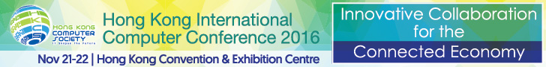
For Immediate Release

Hong Kong International Computer Conference 2016 Commences
Two-day conference enables ICT professionals to capitalise on business opportunities with “Innovative Collaboration for the Connected Economy”
Hong Kong, November 21, 2016 – The Hong Kong International Computer Conference (HKICC) was officially kicked off today with an opening ceremony at the Hong Kong Convention and Exhibition Centre. Organised by the Hong Kong Computer Society and recognised as one of the most popular and highly anticipated ICT conferences in Hong Kong, this year’s two-day annual flagship event is themed “Innovative Collaboration for the Connected Economy”, where delegates can exchange practical information, insights and best practices which will prepare them for the rapid pace of technological change.
Speaking at the opening ceremony today, Mr. Nicholas Yang Wei-hsiung, JP, Secretary for Innovation and Technology, HKSAR Government, said, “Hong Kong has the unique core strengths and edge to take advantage of the connected economy. Big data, IoT, cloud computing and artificial intelligence will become the key driving forces of intelligent Internet. There is an excellent opportunity for Hong Kong to leapfrog in the development of intelligent Internet, in the age of artificial intelligence.”
Dr. NT Cheung, Chairperson of the Hong Kong International Computer Conference 2016 Organising Committee, welcomed the delegates to the conference. He encouraged organisations to better equip themselves and embrace the wealth of new opportunities presented by our ‘Connected Economy’. “With the new wave of digital disruption, change is the dominant factor in driving business forward in a transformed digital world,” said Dr. Cheung. “Organisations are emboldened to step forward and become part of the ‘Connected Economy’, where business values are created through the collaboration between technology, machines, people and organisations. Competing in the ‘Connected Economy’ is definitely a growing focus for the ICT industry.”
“As technology continues to revolutionise people's lives, particularly in the era of the Internet of things (IoT), we are seeing an increased need to highlight the growing potential that lies in the combination of innovation and collaboration,” remarked Mr. Michael Leung, President, Hong Kong Computer Society, during his opening speech at the Conference. “With 39 years of successful history, HKICC will continue to serve as an interactive platform for both local and international ICT delegates to exchange their valuable insights, views and ideas on emerging IT trends. We hope to explore more opportunities and resources to help the ICT industry to capitalise on the explosive demands. Looking ahead, HKCS will continue to act as a hub to attract ICT professionals and experts.”
The two-day conference consists of multiple keynote sessions, individual presentations and panel discussions from high-profile speakers, where they present different topics on emerging IT trends and the best practices in the digital world. Delegates are provided with the latest industry insights on how to harness innovation and collaboration to drive the real benefits to business. As a result, Hong Kong International Computer Conference 2016 marks a milestone for the development of the ICT industry in Hong Kong.

About the Hong Kong International Computer Conference (HKICC)
The Hong Kong International Computer Conference (HKICC) has been organised by the Hong Kong Computer Society (HKCS) since 1978 to provide an open platform for IT professionals in Hong Kong and the region to present their research papers and to share their experience. This annual flagship event is one of the best and most popular ICT conferences in Hong Kong. Nearly 500 delegates attended the conference last year, representing a variety of local and overseas participants from public and private sector organisations, including renowned ICT professionals, academics, executives and senior government officers.
For more details about the event, please visit http://hkicc.hkcs.org.hk/.

About the Hong Kong Computer Society
Founded in 1970, the Hong Kong Computer Society (HKCS) is a recognised non-profit organisation focused on developing Hong Kong's Information Technology (IT) profession and industry. Members hail from a broad spectrum of Hong Kong's IT community, from corporations to like-minded individuals, all coming together to raise the profile and standards of the profession and industry. As a well-established IT professional body, the Society is committed to professional and industry development as well as community services that ensure the IT sector continues to make a positive impact on peoples' lives with three main goals, namely, 1) talent cultivation and professional development, 2) industry development and collaboration, and 3) the effective use of IT in our community.
For more information, please visit http://www.hkcs.org.hk.

– End –
For media enquiries, please contact:
iPR Ogilvy & Mather
Benny Chan / Christina Chan / Roy Tang
Tel: | 3920 7663 / 3920 7674 / 3920 7665
Fax: | 3170 6606
Email: | benny.chan@iprogilvy.com / christina.chan@iprogilvy.com / roy.tang@iprogilvy.com

Hong Kong Computer Society
Coco Wong
Tel: (852) 2834 2228
Email: cocowong@hkcs.org.hk

Photo Caption:
Photo 1:
Speaking at the opening ceremony of Hong Kong International Computer Conference 2016, Mr. Nicholas Yang Wei-hsiung, JP, Secretary for Innovation and Technology, HKSAR Government, said, “Hong Kong has the unique core strengths and edge to take advantage of the connected economy. Big data, IoT, cloud computing and artificial intelligence will become the key driving forces of intelligent Internet. There is an excellent opportunity for Hong Kong to leapfrog in the development of intelligent Internet, in the age of artificial intelligence.”
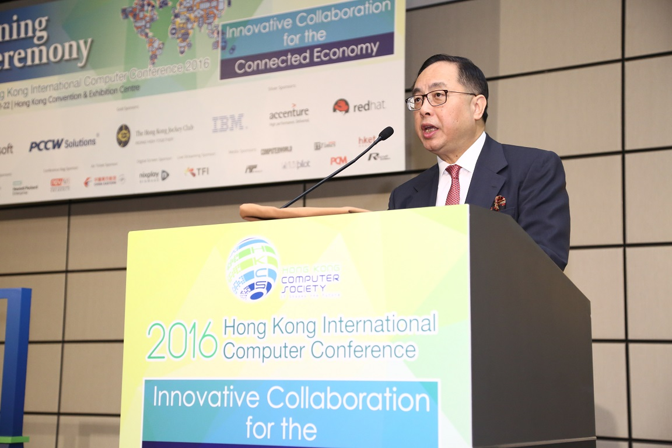
Photo 2:
In his opening speech, Mr. Michael Leung, President of the Hong Kong Computer Society, emphasised that Hong Kong International Computer Conference 2016 will continue to serve as an interactive platform to encourage both local and international ICT delegates to exchange their valuable insights, views and ideas on emerging IT trends.
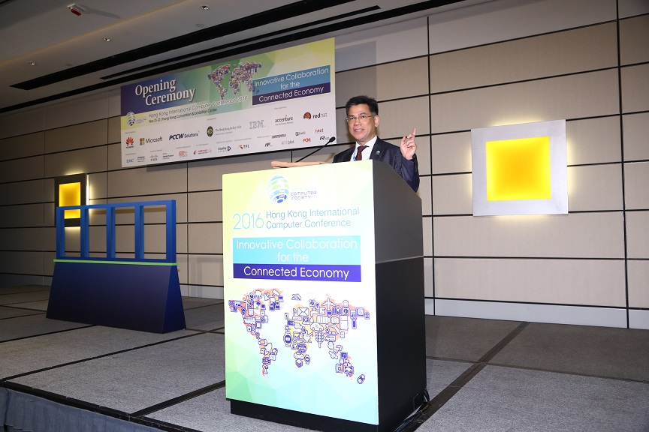
Photo 3:
Dr. NT Cheung, Chairperson of the Hong Kong International Computer Conference 2016 Organising Committee, believes that the ‘Connected Economy’ will be a growing focus for the ICT industry. Organisations are emboldened to step forward and become part of the ‘Connected Economy’, where business values are created through the collaboration between technology, machines, people and organisations.
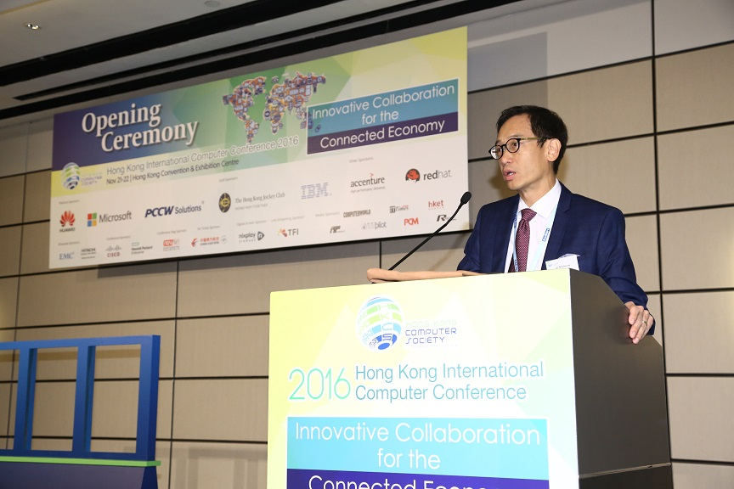
Photo 4:
Mr. Nicholas Yang Wei-hsiung, JP, Secretary for Innovation and Technology, HKSAR Government (2nd left), Dr. NT Cheung, Chairperson of the Hong Kong International Computer Conference 2016 Organising Committee (2nd right), Prof. Patrick Chau, Chairperson of the Hong Kong International Computer Conference 2016 Programme Committee (1st right), and Mr. Michael Leung, President of the Hong Kong Computer Society (1st left), officiated at the opening ceremony of the Hong Kong International Computer Conference 2016, witnessing the official kick-off of the two-day conference.
