
For Immediate Release
Hong Kong Computer Society confers honorary title of Distinguished Fellow upon Professor Roland Chin at 46th Anniversary Dinner
Hong Kong, November 23, 2016 – The Hong Kong Computer Society conferred the honorary title of Distinguished Fellow upon Professor Roland Chin on 22 November at its 46th Anniversary cum Hong Kong International Computer Conference 2016 (HKICC) Gala Dinner, in recognition of his significant and lasting contribution to education, research and the advancement of the ICT industry.

Prof Chin, President and Vice-Chancellor of Hong Kong Baptist University, and former Provost and Deputy Vice-Chancellor and Chair Professor of Computer Science at the University of Hong Kong, has contributed to the research work of computer vision, image processing and pattern recognition. His work has been recognised with accolades such as the US Presidential Young Investigator Award from the National Science Foundation (NSF).
Prof Chin plays many important roles in academia as well as in various industry sectors. Today, he continues to serve as a board member in ASTRI, Hong Kong’s Applied Science and Technology Research Institute, and is also a member of the governmental Advisory Committee on Innovation and Technology, which provides valuable input to the HKSAR government in the formulation of innovation and technology related policies.
“Prof Chin’s contributions to Hong Kong’s ICT industry are highly recognised by the HKCS Council. As a member of the HKCS, Prof Chin unreservedly offers the Society fresh perspective and invaluable advice from time to time,” said Mr. Michael Leung, President of HKCS. “On behalf of HKCS, I would like to convey our warmest congratulations to Prof Chin on his HKCS Distinguished Fellowship conferment.”

Since its introduction in 1987, HKCS has conferred Distinguished Fellowship on a total of 24 eminent members.

About the Hong Kong Computer Society
Founded in 1970, the Hong Kong Computer Society (HKCS) is a recognised non-profit organisation focused on developing Hong Kong's Information Technology (IT) profession and industry. Members hail from a broad spectrum of Hong Kong's IT community, from corporations to like-minded individuals, all coming together to raise the profile and standards of the profession and industry. As a well-established IT professional body, the Society is committed to professional and industry development as well as community services that ensure the IT sector continues to make a positive impact on peoples' lives with three main goals, namely, 1) talent cultivation and professional development, 2) industry development and collaboration, and 3) the effective use of IT in our community.
For more information, please visit http://www.hkcs.org.hk.

– End –
For media enquiries, please contact:
iPR Ogilvy & Mather
Benny Chan / Christina Chan / Roy Tang
Tel: | 3920 7663 / 3920 7674 / 3920 7665
Fax: | 3170 6606
Email: | benny.chan@iprogilvy.com / christina.chan@iprogilvy.com / roy.tang@iprogilvy.com

Hong Kong Computer Society
Coco Wong
Tel: (852) 2834 2228
Email: cocowong@hkcs.org.hk

Photo Caption:

Photo 1:
Mr. Michael Leung, President of the Hong Kong Computer Society, presented a souvenir to thank Mr. David Chung, Under Secretary for Innovation and Technology, HKSAR Government, for his presentation at the Hong Kong International Computer Conference this year.
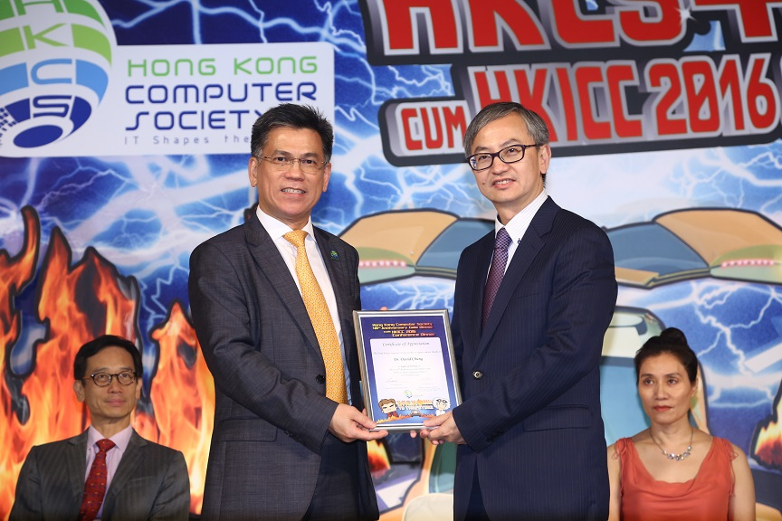

Photo 2:
The Hong Kong Computer Society conferred the honorary title of Distinguished Fellow upon Prof. Roland Chin, President and Vice-Chancellor of Hong Kong Baptist University, in recognition of his significant and lasting contribution to education, research and the advancement of the ICT industry.
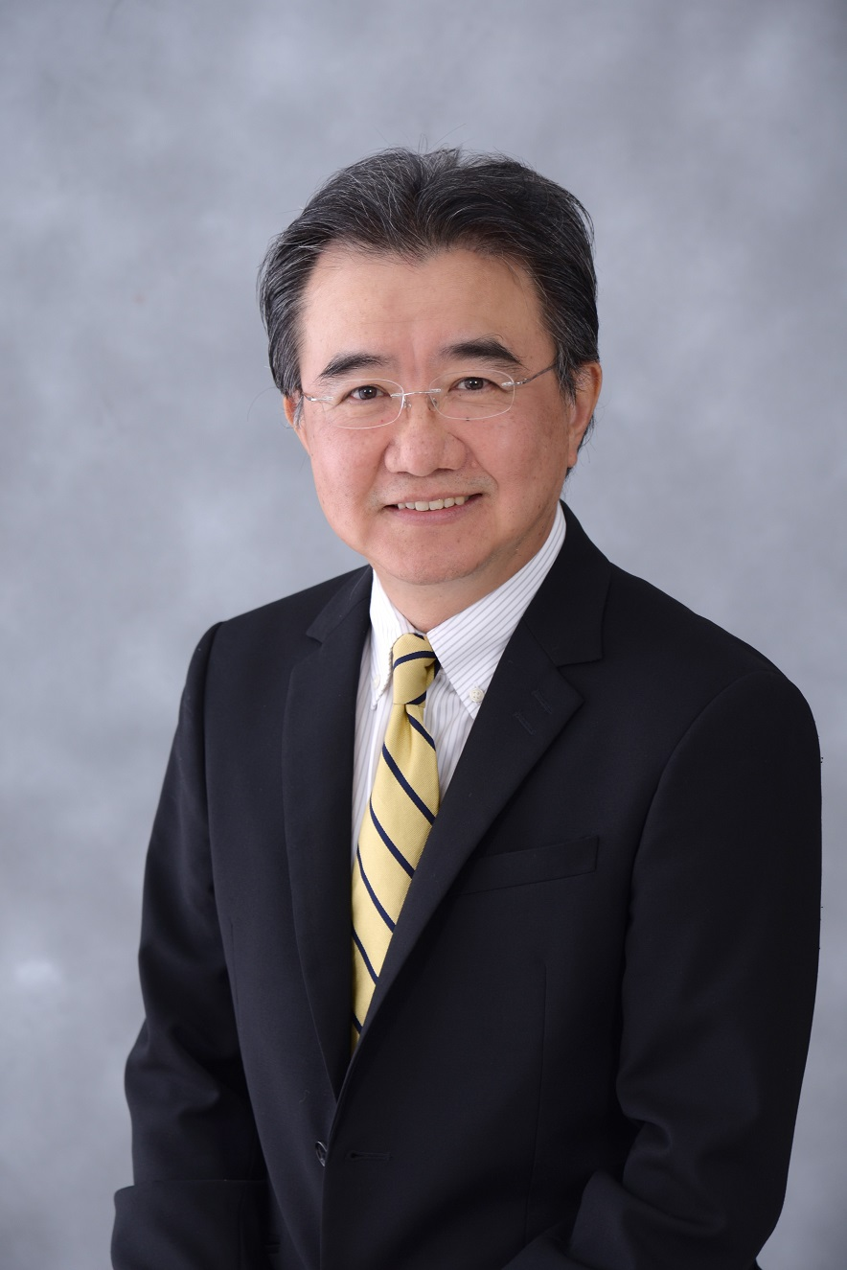
Photo 3:
Mr. Michael Leung, President of the Hong Kong Computer Society, expressed appreciation for Prof. Chin’s contribution to Hong Kong’s ICT industry and the Hong Kong Computer Society, and conveyed warm congratulations to Prof. Chin on his HKCS Distinguished Fellow conferment.
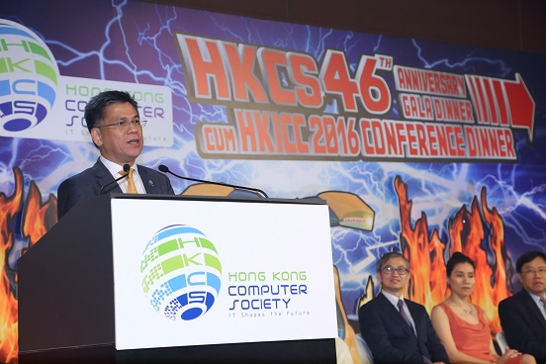

Photo 4:
The 46th anniversary of the Hong Kong Computer Society and the successful conclusion of the Hong Kong International Computer Conference 2016 were celebrated with a toast by the honorable guests.
