For Immediate Release

FACE Charity Walk x Family Fun Day
Raising Funds for The Women’s Foundation “Girls Go Tech Programme”

Hong Kong, 14 May 2017 – Organised by the FACE Club of the Hong Kong Computer Society and co-organised by the Hong Kong Computer Society Foundation, FACE Charity Walk x Family Fun Day was successfully concluded at Cyberport today, with the aim of raising funds to help underprivileged girls engage in technology-related activities via the “Girls Go Tech Programme” of The Women’s Foundation. About 300 participants attended the event. The walk was followed by a family fun session filled with live music and an array of game booths such as a VR game, robot football match and DIY handicraft workshop.

The FACE Club Charity Walk was kicked off by Hon. Charles Peter Mok, JP, Legislative Councillor, Functional Constituency of Information Technology, HKSAR, Mr. Michael Leung, President of the Hong Kong Computer Society, Ms. Candy Liu, Chairperson of the Hong Kong Computer Society FACE Club Charity Walk Organising Committee, Ms. Cally Chan, Chairperson of the Hong Kong Computer Society FACE Club, Ms. Susan Hutchison, Board Chair of The Women’s Foundation, Ms. Winnie Young Yuen Yee, Chairman of the Board of Trustees of Wai Yin Association 2015-2020, Ms. Dionne Lam, Wai Yin Association 35th Anniversary Project Committee Member and Ms. Edith Wong, Member of Wai Yin Association.

The FACE Club held its very first charity walk on Mother’s Day not just for the celebration of its second anniversary, but also to raise funds to help junior secondary school girls from underprivileged backgrounds to pursue STEM (Science, Technology, Engineering, Mathematics) activities, aiming to raise women’s opportunities in the ICT industry. The walk consisted of three categories – corporate, individual and family. The 2km walk started at Cyberport and followed the route to Information Crescent, Cyberport Road and Cyberport Waterfront Park.

Ms. Cally Chan, Chairperson of the Hong Kong Computer Society FACE Club, remarked, “FACE Club is the first IT women’s club in Hong Kong. By organising different kinds of IT-related activities, we strive to attract more females to this industry and to pursue their career in ICT.”

Ms. Candy Liu, Chairperson of the Hong Kong Computer Society FACE Club Charity Walk Organising Committee, stated, “We are delighted to have generous support from many corporations. They have even formed teams to participate in the event. We hope that more people from all walks of life can make donations to support school girls from underprivileged backgrounds.”

All proceeds of “FACE Charity Walk x Family Fun Day” after costs are deducted will be donated to The Women’s Foundation “Girls Go Tech Programme”. The public can learn more about the programme and make donations directly at https://twfhk.org/girls-go-tech-programme.
Event website: www.facecharitywalk.org
Facebook: fb.com/hkcs1970

About Hong Kong Computer Society
Founded in 1970, the Hong Kong Computer Society (HKCS) is a recognised non-profit organisation focused on developing Hong Kong's Information Technology (IT) profession and industry. Members hail from a broad spectrum of Hong Kong's IT community, ranging from corporations to like-minded individuals, all coming together to raise the profile and standards of the profession and industry. As a well-established IT professional body, the Society is committed to professional and industry development as well as community services that ensure the IT sector continues to make a positive impact on peoples' lives with three main goals, namely, 1) talent cultivation and professional development, 2) industry development and collaboration, and 3) the effective use of IT in our community. For more information, please visit http://www.hkcs.org.hk/.

About the FACE Club
FACE Club is the first IT women’s club in Hong Kong organised by the Hong Kong Computer Society. FACE stands for “Female”, “Attract”, “Connect” and “Engage”, which implies the objectives of FACE Club: To ATTRACT more FEMALES to choose ICT as their career; to CONNECT existing HKCS female members, and to provide opportunities for our female members to ENGAGE in Hong Kong ICT and HKCS activities.

– End –

For media enquiries, please contact:
iPR Ogilvy & Mather
Benny Chan / Roy Tang
Tel: | 3920 7663 / 3920 7665
Fax: | 3170 6606
Email: | benny.chan@iprogilvy.com / roy.tang@iprogilvy.com

Hong Kong Computer Society

Coco Wong
Tel: 2834 2228
Email: cocowong@hkcs.org.hk

Photo Caption:

Photo 1:
Ms. Cally Chan, Chairperson of the Hong Kong Computer Society FACE Club, remarked, “FACE Club is the first IT women’s club in Hong Kong. By organising different kinds of IT-related activities, we strive to attract more females to this industry and to pursue their career in ICT.”
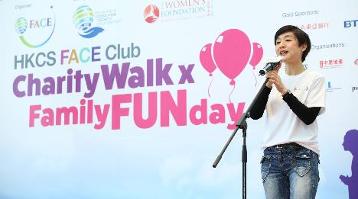

Photo 2:
Ms. Candy Liu, Chairperson of the Hong Kong Computer Society FACE Club Charity Walk Organising Committee, stated, “We are delighted to have generous support from many corporations. We hope that more people from all walks of life can make donations to support school girls from underprivileged backgrounds.”
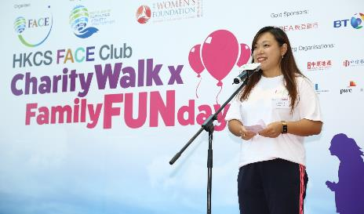

Photo 3:
Mr. Michael Leung, President of the Hong Kong Computer Society, expressed his gratitude to the FACE Club Charity Walk Organizing Committee, sponsors and donors, and welcomed all the participants of the FACE Charity Walk x Family Fun Day.
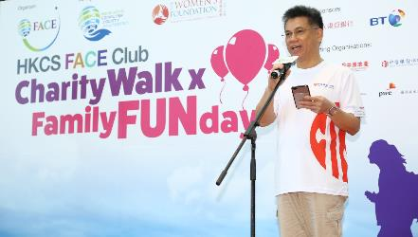
Photo 4:
Hon. Charles Peter Mok, JP, Legislative Councillor, Functional Constituency of Information Technology, HKSAR (3rd right, back roll), Mr. Michael Leung, President of the Hong Kong Computer Society (6th right, front roll), Ms. Candy Liu, Chairperson of the Hong Kong Computer Society FACE Club Charity Walk Organising Committee (4th left, front roll), Ms. Cally Chan, Chairperson of the Hong Kong Computer Society FACE Club (5th left, front roll), Ms. Susan Hutchison, Board Chair of The Women’s Foundation (middle, front roll), Ms. Winnie Young Yuen Yee, Chairman of the Board of Trustees of Wai Yin Association 2015-2020 (6th left, front roll), Ms. Dionne Lam, Wai Yin Association 35th Anniversary Project Committee Member (6th right, back roll) and Ms. Edith Wong, Member of Wai Yin Association (2nd right, back roll) in the FACE Charity Walk x Family Fun Day.
Photo 5:
About 300 participants attended the FACE Charity Walk x Family Fun Day organised by the FACE Club of the Hong Kong Computer Society and co-organised by the Hong Kong Computer Society Foundation at Cyberport.
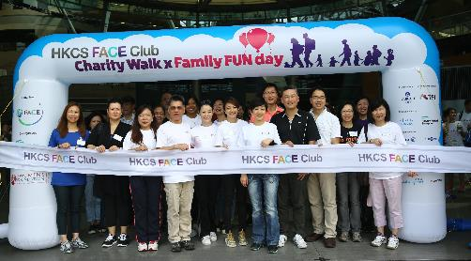
Photo 6:
Followed by the charity walk, participants enjoyed the family fun session filled with live music and an array of game booths such as a VR game, robot football match and DIY handicraft workshop.

