Corporate Membership  Application Form | FOR OFFICE USE ONLY
Corporate Membership  Application Form | Application Ref:
Corporate Membership  Application Form | Membership No:
Corporate Membership  Application Form | Membership Class:
Corporate Membership  Application Form | Approved By:
Corporate Membership  Application Form | Payment:
Corporate Membership  Application Form | Processed By:

Please cross (X) the appropriate box.
Corporate Membership Package
Diamond | Platinum | Gold

Year(s) of subscription
1-year subscription | 2-year subscription

We are a member/partner of:
ACW Distribution | Fujifilm | HKBN iTEA | OASES | None of the above

NOTES:
- A Corporate Member may nominate a certain number of its employees or directors for admission to individual membership (Full, Associate, or General class only, subject to the applicable membership requirements) in accordance with the number of individual membership entitlements outlined in the corresponding Corporate Membership Package. These members shall be exempt from admission and annual subscription fees. The nomination or change of such membership is subject to the approval of the Membership Committee. Please [click here] to view the membership package details.
- The application MUST be accompanied by a photocopy of the Business Registration and completed individual membership application form(s).
- The processing time for a membership application is approximately 3 weeks.

Please fill in all sections in BLOCK LETTERS. In any section of the Application Form is not applicable, please write ‘N/A’.
Company Name:
Company Address:
Contact Person: |  | Position:
Office Tel. No: | Ext. ( ) | Office Fax No:
Email: |  | Website:

DECLARATION
I/We hereby apply for a Corporate Member and agree to be bound by, perform and observe the following terms and conditions:

- If admitted to the Society, I/We undertake to be bound by the Constitution of the Society, as amended from time to time.
- I/We understand that the Membership Committee of the Society reserves the right to approve or reject the membership application of any individual.
- I/We understand that the personal data provided in this form is collected for the Society’s administration and correspondence purposes only. This data might be used to inform me about IT-related activities organised by the Society and other organisations.
- In an ongoing effort to enhance members' recognition and communication, I/We understand that our company profile and logo will be displayed on the HKCS website.
- I/We understand that the subscription payments are due annually in the month in which the membership fee was initially paid upon approval of membership.
- I/We understand that it is permissible to change any nominated member(s) free-of-charge once a year when renewing the membership. Any changes to nominated member(s) should be communicated to the HKCS Secretariat within one month of the renewal date. Otherwise, an administration charge of HK$200 will be applied per each nominated member change.
- The membership period of the nominated members will be synchronised with the membership period of the corporate membership to which they belong.
- I/We acknowledge that if membership renewal is processed within 3 months after expiration, it will be extended for 12 months from the expiration date. Renewal within 3 to 6 months after expiration will also result in a 12-month extension from the expiration date, accompanied by an extra HK$300 overdue handling charge. Renewal exceeding 6 months after expiration will entail a 12-month extension from the renewal date, along with a HK$450 overdue handling charge.

Official Chop & Signature Date
Personal Data (Privacy) Notice - Use of Personal Data

People who supply data in their application to the HKCS are advised to note the following points, pursuant to the Personal Data (Privacy) Ordinance:

- Personal data provided in this application form will, during the entire process, be used solely for this purpose, and in this connection, the data will be handled by the Society’s staff or by any Council members of the Society who is directly involved in the administration of this application.
- Applicants are advised to provide all the information requested in the relevant documents, where applicable, failing which the Society may be unable to process and consider their applications.
- After the applications have been processed and the relevant exercise completed:
(a) the information collected from unsuccessful candidates will be destroyed;
(b) the application papers of successful candidates will become part of the file which the Society opens for each member.
- Under the provisions of the Personal Data (Privacy) Ordinance, applicants have rights to request access to, and to request the correction of, their personal data. Applicants wishing to access or make corrections to their data should submit written requests to the HKCS Membership Committee.

Declaration
- I have taken note of the key provisions under the Personal Data (Privacy) Ordinance.
- I authorise HKCS or any other office that is directly involved in the administration of this application to use, verify and process my data as necessary for my application.
- I acknowledge that upon successful application, my data will be incorporate into my member record and may be utilised for all purposes as outlined in the relevant rules and regulations, for as long as I remain a member of this Society.
- I affirm that the information provided in support of this application is accurate and complete. I understand that any falsification will result in disqualification of my application.

Official Chop & Signature Date

Industry Code List (Please choose 1):
 |  | Accounting/Audit/Tax Services |  |  | Food and Beverage |  |  | Mixed Industry Group
 |  | Advertising/Public relations/Marketing Services |  |  | Freight Forwarding/Delivery/Shipping |  |  | Motor Vehicles
 |  | Architecture/Building/Construction |  |  | General Business Services |  |  | Packaging
 |  | Athletics/Sports |  |  | Health & Beauty Care |  |  | Performance/Musical/Artistic
 |  | Banking |  |  | Hospitality/Catering |  |  | Petroleum
 |  | Charity/Social Services/Non-Profit Organisation |  |  | Human Resources Management/Consultancy |  |  | Property Development
 |  | Chemical/Plastic/Paper/Petrochemical |  |  | Industrial Machinery/Automation Equipment |  |  | Property Management/Consultancy
 |  | Civil Services (Government, Armed Forces) |  |  | Information Technology |  |  | Public Utilities
 |  | Clothing/Garment/Textile |  |  | Insurance/Pension Funding |  |  | Research/Survey
 |  | Education |  |  | Interior Design/Graphic Design |  |  | Security Escort
 |  | Electronics/Electrical Equipment |  |  | Jewellery/Gems/Watches |  |  | Security/Fire/Electronic Access Controls
 |  | Energy/Power/Water/Oil & Gas/Waste Management |  |  | Laboratory |  |  | Telecommunication
 |  | Engineering - Building, Civil, Construction / Quantity Survey |  |  | Legal Services |  |  | Tourism/Travel Agency
 |  | Engineering - Electrical/Electronic/Mechanical |  |  | Management Consultancy/Service |  |  | Toys
 |  | Engineering - Others |  |  | Manufacturing |  |  | Trading and Distribution
 |  | Entertainment/Recreation |  |  | Mass Transportation |  |  | Wholesale / Retail
 |  | Environmental Science |  |  | Media/Publishing/Printing |  |  | Others
 |  | Financial Services |  |  | Medical/Pharmaceutical

Job Nature Code List (You may select more than one option, with a maximum limit of 3 choices):
A |  | Application Specialist - Network | G |  | Application Specialist - Software | M |  | DBA
B |  | Hardware | H |  | IT - Webmaster / SEO | N |  | IT Auditing
C |  | IT Management | I |  | IT Project Management / Team Lead | O |  | Mobile / Wireless Communications
D |  | Network & System | J |  | Product Management / Business Analyst | P |  | Security
E |  | Software Development | K |  | Support | Q |  | Technical / Functional Consulting
F |  | Technical Writing | L |  | Testing / QA | R |  | Others

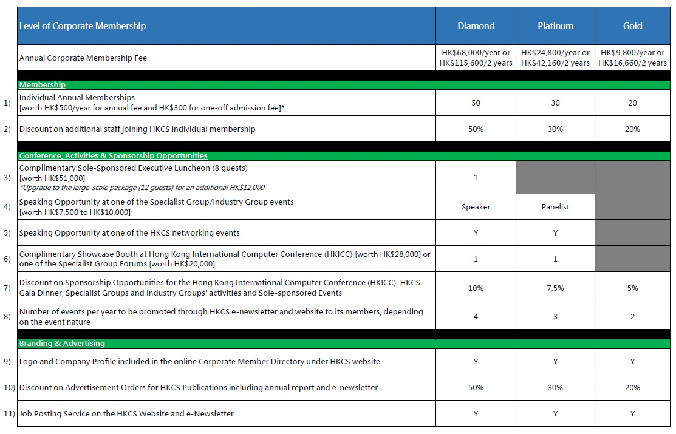
Corporate Membership Packages

