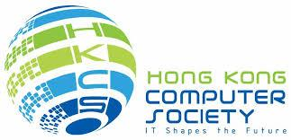
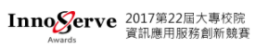
Updated on Nov 9, 2017
For Immediate Release
Hong Kong Students Win First and Third Prizes
in International ICT Innovative Services Awards 2017 (InnoServe 2017)

Hong Kong ICT young talent showcases innovation in InnoServe 2017
and well performs Hong Kong’s advancement in artificial intelligence and robotics

Hong Kong, November 9, 2017 – The International ICT Innovative Services Awards 2017 (InnoServe 2017), took place on 4 November in Taipei, concluded with a great success for Hong Kong. Two teams of Hong Kong students, winners from the China Pan-Pearl River Delta Region University IT Project Competition 2017 and nominated and sponsored by Hong Kong Computer Society (HKCS), won the first and third prizes respectively in the Asia Pacific International category of InnoServe 2017.
The InnoServe Awards aims to provide platform for students to present their information management projects as part of their graduation requirements; while at the same time, promoting academic-industry collaboration by integrating academic training and practical experience. There are nearly 2,500 teachers and students with almost 400 teams from over one hundred universities and colleges in Asia Pacific participated in the contest.
Law Chor-hon, Jimmy and Hu Shengjie, Jason, who won the first place in IC1(InnoServe Contest) and third place in IC2 respectively under the Asia Pacific International Category, are the Gold Award winners from the China Pan-Pearl River Delta Region University IT Project Competition 2017. They both come from The University of Hong Kong studying Computer Science. Jimmy Law has also been nominated to participate in the coming Asia Pacific ICT Awards (APICTA) which will be held from 7-10 December in Bangladesh.
“We are very delighted to have both nominated entries being awarded. We can see Hong Kong advances in AI and robotics among the Asia Pacific region. It is impressive to see Hong Kong students demonstrating their talent in innovation and practical application of their ideas.”, said Ir Stephen Lau, JP, Secretary General (Hon) of HKCS.
The winning entry of Law Chor-hon, Jimmy is called “Sensor Controlled Robotic Hand with Haptic Feedback”. The robotic hand will have measure on pressure bearing and provide haptic feedback to the sensor glove so operator can feel the same. Operator can control the robotic hand to perform tasks even with no visual information. The glove will measure the force that operator applies and the robotic hand will apply a similar force. It is crucial in performing precise tasks such as holding fragile objects like eggs. Therefore, it would be a good idea for further developed as rescue robots in hazardous environment as well as providing immersive gaming experience in gaming industry.
Another winning entry is called “Deep-learned Pedestrian Avoidance Policy for Robot Navigation” by Hu Shengjie, Jason. Robot operating system (ROS) builds bridges from sensing and vision inputs to collaborative decision making and finally to the steering command output that acts on the robot. With Deep neural networks and Ultrasonic sensors, the training process of the device is advantageous over model-based because it is an end-to-end method, and requires less time in labeling.

About the International ICT Innovative Services Awards 2017 (InnoServe 2017)
Entering its 22th year, the International ICT Innovative Services Awards (InnoServe Awards) is an annual ICT application competition held for university and college students in Chinese Taipei. In 2004, the Chinese Society for Information Management, in collaboration with Taiwan authorities and the Taipei Computer Association, expanded the scale of the contest to become the largest and the most significant contest of its kind in Taiwan.
For more details about the event, please visit https://innoserve.tca.org.tw/en/index.aspx

About the Hong Kong Computer Society
Founded in 1970, the Hong Kong Computer Society (HKCS) is a recognised non-profit organisation focused on developing Hong Kong's Information Technology (IT) profession and industry. Members hail from a broad spectrum of Hong Kong's IT community, ranging from corporations to like-minded individuals, all coming together to raise the profile and standards of the profession and industry. As a well-established IT professional body, the Society is committed to professional and industry development as well as community services that ensure the IT sector continues to make a positive impact on peoples' lives with three main goals, namely, 1) talent cultivation and professional development, 2) industry development and collaboration, and 3) the effective use of IT in our community.

For more information, please visit http://www.hkcs.org.hk.

– End –

For media enquiries, please contact:

Hong Kong Computer Society

Coco Wong
Tel: | 2834 2228
Email: | cocowong@hkcs.org.hk

Photo Caption:
Photo 1:
Hong Kong student, Law Chor-hon, Jimmy won the first place in IC1(InnoServe Contest).
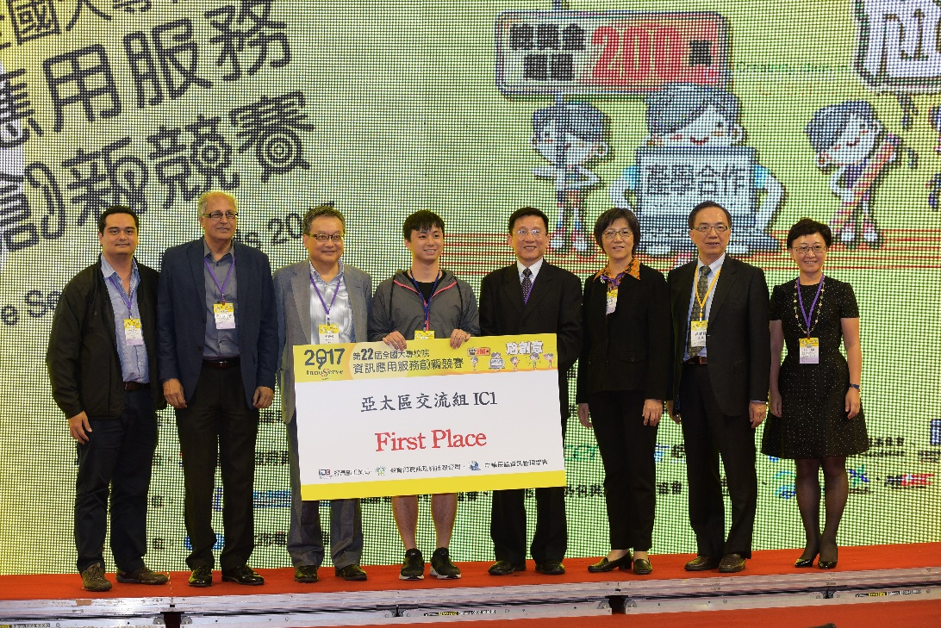

Photo 2:
The two Hong Kong winners, namely Law Chor Hon, Jimmy (left) and Hu Shengjie, Jason (right) speak on stage.
