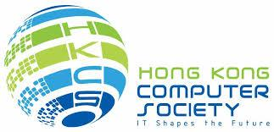

For Immediate Release
Hong Kong Computer Society
Newly Launched IT LEadership Accelerator Platform (iLEAP)
Demonstrates Commitment to Nurturing Competent IT Leaders
Latest insights reveal that shortage in IT resources and talent, cyber and information security, and encouraging innovation are top issues for CIOs
Hong Kong, 22 March 2017 – The Hong Kong Computer Society (HKCS) officially launched the IT LEadership Accelerator Platform (iLEAP) during the iLEAP Inaugural Ceremony cum CIO Board 10th Anniversary event held yesterday. CIOs, IT managers and professionals from different industry sectors, and from prominent companies and organisations, gathered to celebrate this grand occasion, while at the same time networking with other industry peers.
To address the issue of talent shortage in the IT industry, HKCS established iLEAP, a professional and leadership development platform, to help IT managers overcome obstacles they face in seeking further career progress in the digital economy, through various activities and programmes that will be led by the iLEAP Executive Committee under the auspices of the HKCS Council and the CIO Board (CIOB).
As one of the key iLEAP initiatives, for example, a one-year mentoring programme will introduce a one-on-one best possible mentor-mentee match based on each applicant’s needs and preferences, while all mentors assigned will be senior IT executives or CIOB members. Other activities include meetings with CIOs, management workshops and digital forums, study missions and exchanges, and industry social gatherings for members to broaden their horizons and explore potential opportunities in the industry.
At the inaugural ceremony, Mr. Ted Suen, Chairperson of iLEAP, stated, “In recent years, we have noted a shortage of competent and effective IT management talent, such as Chief Information Officers (CIO), Heads of IT and senior executives, among both business users and service providers in Hong Kong. As the roles and responsibilities of CIOs are becoming increasingly vital for all sectors – enterprises, public bodies, tertiary institutions as well as banking and financial organisations – we expect that iLEAP can effectively accelerate the growth of the local IT talent pool, which will in turn help promote IT development in Hong Kong.”
All HKCS members having 10 or more years’ IT-related work experience with at least 3 years in managerial role are eligible to apply for iLEAP membership. Once the application is approved, the applicant will become an official member of iLEAP.
Ms. Susanna Shen, Chairperson of the CIO Board, remarked, “We are delighted to make a continuing commitment to nurturing potential IT leaders to further their career prospects through participating in iLEAP. This year is the 10th anniversary of the CIO Board, which was established by a group of members comprised of CIOs from local prominent companies and organisations. As a group focused on sharing industry insights, the CIO Board is a valuable and effective platform for CIOs to share their views, issues, challenges, insights, best practices and experiences amongst themselves and with potential CIOs, as well as with other key industry stakeholders. The CIO Board also serves to collect views on matters of common interest related to ICT, consolidate such views and submit them to relevant parties.”
At the CIO Board’s 10th anniversary event, HKCS’s CIOB in collaboration with the PolyU IAEE Leadership Programme highlighted the insights into top agenda, challenges, technology priorities amongst local prominent CIOs in their respective sectors, with the key highlights as follows:
- Top three on the agenda for CIOs in Hong Kong are “Addressing IT Resources/Talent Shortage”, “Addressing Cyber/Information Security” and “Encouraging Innovation”. [See appendix 1] , which are consistent with CIOs’ top four challenges mentioned in the report. They are “Cyber/information Security”, “Talent Gap/Shortage”, “Shortage of Human Resources” and “Meeting Users Demands/Expectations” . [See appendix 2]
- Among various technologies, “Big Data Analytics”, “Cloud Computing” and “Business Intelligence/Analytics” are the top three priorities for CIOs, followed by “Mobility” and “Internet of Things” . [See appendix 3]
- Most of local CIOs will increase IT expenditure or have it remained the same in the coming year. Such expenditure will include “Ongoing service and maintenance”, “Renewal and replacements”, as well as “Business transformation/innovation ”
Ms. Susanna Shen said, “With reference from local prominent CIOs’ insights, the shortage in IT resources and talent, cyber and information security, and encouraging innovation are CIOs’ top concerns. It also underscores the trend of increasing IT expenditure. Apart from ongoing service and maintenance along with equipment renewal and replacement, CIOs will have to invest in business transformation and innovation. In the future, we hope to see CIOs tackling emerging IT challenges as leaders, and achieving great success in their companies and for the industry.”
Mr. Michael Leung, President of the Hong Kong Computer Society, remarked, “We believe that there is no shortcut to creating professional IT executives in top management. To be a competent CIO, one must be equipped with well-rounded professional skills spanning technical knowledge, strong leadership expertise, business acumen, exemplary communication ability and appreciation of emerging technologies in order to prepare companies to address the challenges for digital transformation. We have high hopes for iLEAP to become a great success, by providing a unique professional and leadership development platform with mentorship, training and collaboration opportunities which best foster the career growth of IT executives and complement HKCS’s commitment to IT development.”

About the Hong Kong Computer Society
Founded in 1970, the Hong Kong Computer Society (HKCS) is a recognised non-profit organisation focused on developing Hong Kong's Information Technology (IT) profession and industry. Members hail from a broad spectrum of Hong Kong's IT community, ranging from corporations to like-minded individuals, all coming together to raise the profile and standards of the profession and industry. As a well-established IT professional body, the Society is committed to professional and industry development as well as community services, that ensure the IT sector continues to make a positive impact on peoples' lives with three main goals, namely, 1) talent cultivation and professional development, 2) industry development and collaboration, and 3) the effective use of IT in our community.

For more information, please visit http://www.hkcs.org.hk.
– End –

For media enquiries, please contact:
iPR Ogilvy & Mather
Benny Chan / Christina Chan / Roy Tang
Tel: | 3920 7663 / 3920 7674 / 3920 7665
Fax: | 3170 6606
Email: | benny.chan@iprogilvy.com / christina.chan@iprogilvy.com / roy.tang@iprogilvy.com

Hong Kong Computer Society

Coco Wong
Tel: 2834 2228
Email: cocowong@hkcs.org.hk

Appendix 1: Top 10 CIO Agenda
 | Agenda
1 | Addressing IT Resource/Talents Shortage
2 | Addressing Cyber/Information Security
3 | Encouraging Innovation
4 | Implementing DevOps
5 | Implementing Business Intelligence / Analytics
6 | Mobility
7 | Extending BI/Analytics to encompass unstructured Data
8 | Implementing Cloud Computing services/solutions
9 | Applying Artificial Intelligence
10 | Making IT costs/investments more effective

Appendix 2: Top 10 CIO Challenges
 | Challenge
1 | Cyber/information security
2 | Talent Gap/Shortage
3 | Shortage of Human Resources
4 | Meeting Users demand/expectations
5 | IoT Security
6 | Renewal/Replacement of software
7 | Renewal/Replacement of IT infrastructure
8 | Pressure for costs reduction
9 | IT Governance
10 | Lack of Enterprise Architecture

Appendix 3: Top 10 CIO Technology Priorities
 | Technology
1 | Big Data Analytics
2 | Cloud Computing
3 | Business Intelligence / Analytics
4 | Mobility
5 | Internet of Things
6 | Artificial Intelligence (AI)
7 | Virtualization
8 | Chatbot
9 | Advance Machine Learning
10 | Collaboration Technologies

Photo Captions
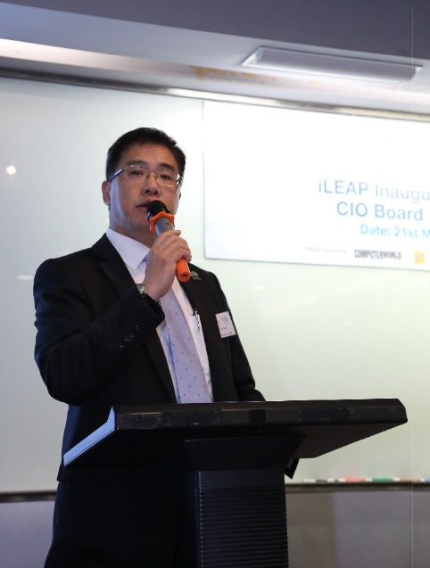
Photo 1: At the iLEAP Inaugural Ceremony cum CIO Board 10th Anniversary event, Mr. Ted Suen, Chairperson of iLEAP, remarked, “The launch of iLEAP aims to help effectively accelerate the growth of local IT talent pool, which will in turn help promote IT development in Hong Kong.”
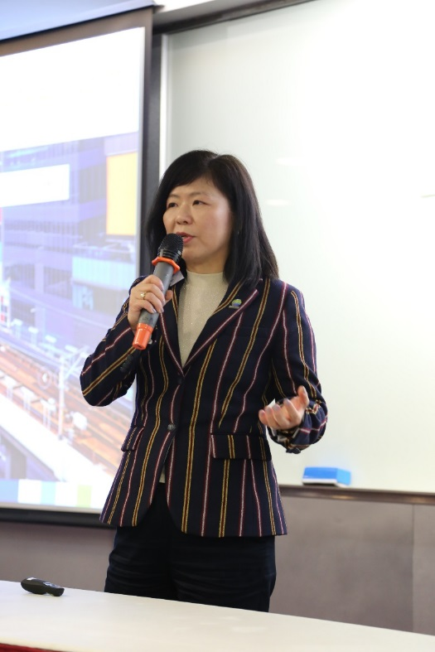
Photo 2: At the CIO Board’s 10th anniversary event, Chairperson of the CIO Board, Ms. Susanna Shen highlighted the insights into top agenda, challenges and technology priorities amongst local prominent CIOs in their respective sectors.

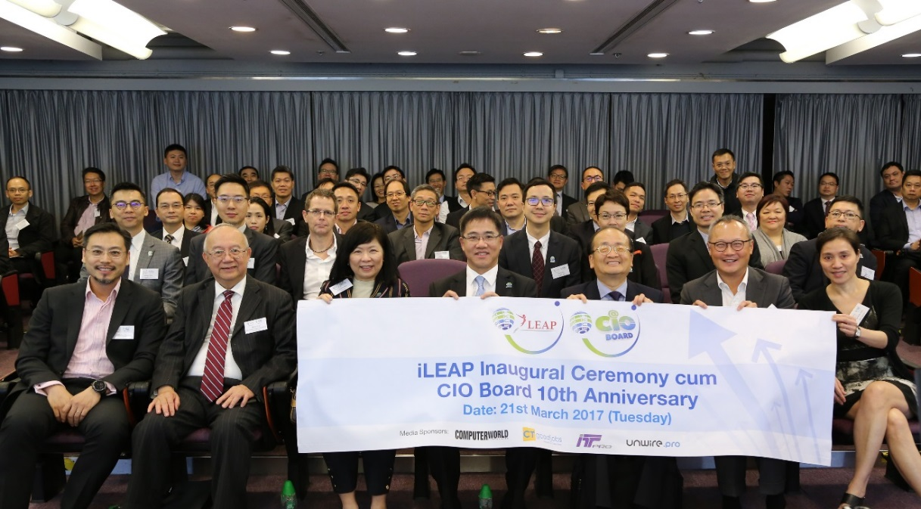
Photo 3: Ted Suen, Chairperson of iLEAP (First roll Middle), and Susanna Shen, Chairperson of CIO Board (First roll Third Left) in a group picture with other key attending guests, at the iLEAP Inaugural Ceremony cum CIO Board 10th Anniversary event.
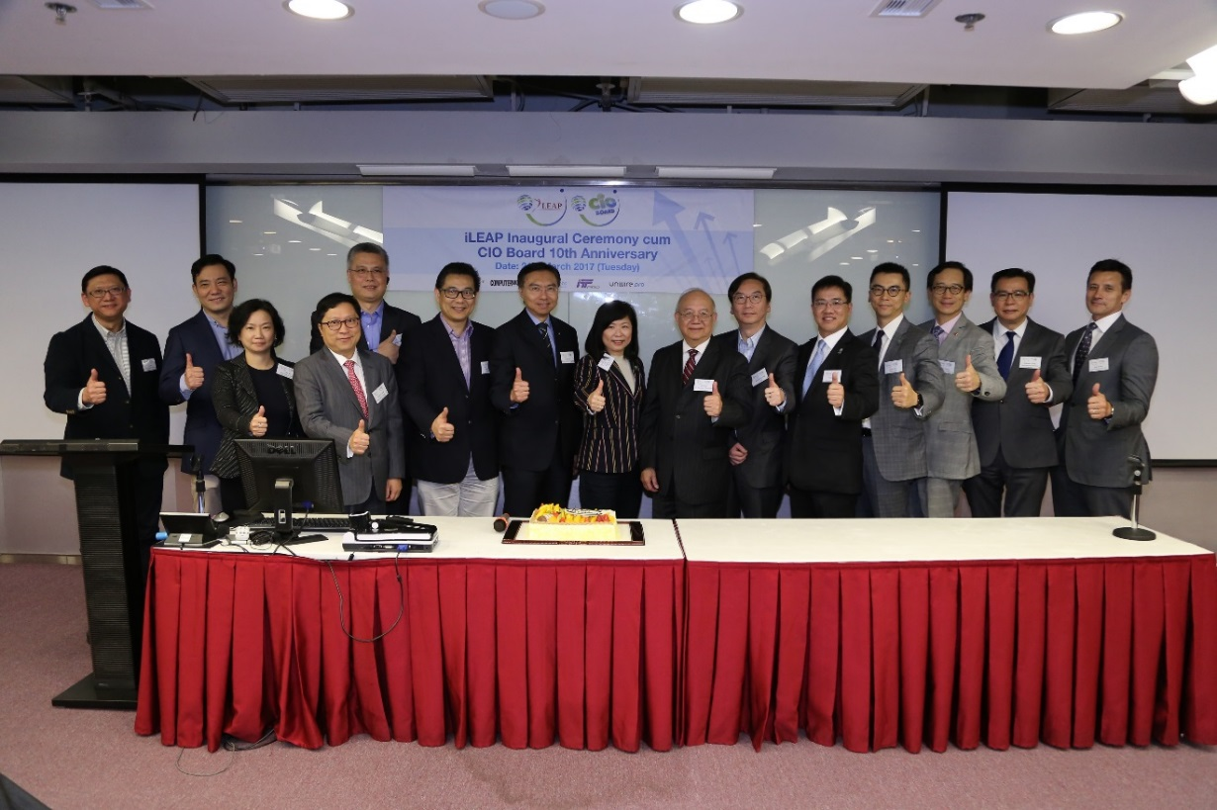

Photo 4: CIOs, IT managers and professionals from different industry sectors, and from prominent companies and organisations, gathered to celebrate the inauguration of iLeap and the 10th Anniversary of the CIO Board of the Hong Kong Computer Society.
***

