For Immediate Release
Hong Kong Computer Society Survey Reveals Extensive Gap between Employers and IT Talent on career expectations

- Survey highlights a significant gap in expectations between employers and IT talent in regard to job nature, salary, benefits and working environment
- HKCS IT Career Expo serves as a platform to bridge the gap between employers and IT talent
Hong Kong, 11 March, 2017 – At the IT Career Expo 2017, the Hong Kong Computer Society (HKCS) today unveiled a survey entitled “IT Industry Employment and Salary Trends”, jointly conducted with CTgoodjobs, where 100 companies and 150 job seekers were interviewed with an aim of understanding the IT career recruitment landscape in Hong Kong and identifying any related disparities between the two groups. The survey revealed significant differences in expectations between employers and job seekers on job offerings in regards to the job nature, salary, benefits and working environment.
Major findings of the “IT Industry Employment and Salary Trends” survey were: -

- Of the various IT-related positions, those of programmer / analyst programmer are in the highest demand by employers (24%). However, only 7% of job seekers are most interested in such positions. [See Appendix 1]

- 66% of job seekers consider flexible working schedules / work-life balance as one of the most important factors (ranking second among the available options) when considering offers, while only 21% of employers are willing to offer such initiatives to recruit or retain IT talent (ranking the lowest among available options). [See Appendix 2]

- 70% of companies think that offering competitive pay / compensation is a first priority for recruiting and retaining IT talent, followed by providing training (47%) and good working conditions (44%). 20% of the job seekers responded that higher salary / more job stability is considered top of the agenda in a job search, while overcoming limited career advancement / opportunity for growth (27%) in a current position, and pursuing a better match for skills, experience and aspirations (26%) in a new move, were both rated more important. [See Appendix 2]

- Most employers (34%) are willing to offer HKD $14,000 - HKD $16,000 as a salary for entry level IT employees, while most (32%) entry level IT job seekers are looking for a salary of more than HKD $20,000. [See Appendix 3]
Mr. Jackie Wong, Chairperson of the HKCS IT Career Expo 2017 Organising Committee, commented, “From the discrepancies in points of view offered in the survey, we see a significant mismatch between the expectations of employers and IT talent towards job offerings. While it is generally agreed by the employers that offering competitive pay would be key, it is however career advancement and pursuing a better match to skills, experience and aspirations which is of most concern to job seekers. In this light, I believe that greater understanding on both sides will be required to bridge the gap for IT talent recruitment while helping promote IT development in Hong Kong and eliminating the shortage of IT talent.”

The Hong Kong Computer Society IT Career Expo 2017, organised by the Hong Kong Computer Society (HKCS), supported by the Innovation and Technology Bureau (ITB), the Education Bureau’s Business-School Partnership Programme (BSPP) and the Hong Kong Productivity Council, together with exclusive recruitment partner CTgoodjobs, was held today at the Hong Kong Productivity Council. As the only expo providing one-stop IT career information with job and continuing study opportunities for the public in Hong Kong, and a series of activities including exhibitions, seminars and sharing sessions focusing on “Employment”, “Start-up” and “Continuing Education”, supported by 40+ exhibitors ranging from the banking, technology and telecommunications sectors to academic institutions, featured over 500 IT-related positions, IT Career Expo 2017 was a fruitful and successful event helping bridge the needs between employers, institutions and IT Talent and helping make Hong Kong’s IT development more competitive and rewarding.
Mr. Michael Leung, President of the Hong Kong Computer Society, remarked, “This is the fifth year HKCS has hosted the HKCS IT Career Expo, and we are once again very pleased to see it serving as a platform that connects institutions, employers, IT entrepreneurs and IT talents, with an aim of bringing together wonderful diversity in expertise and creativity of all parties to eliminate the IT talent shortage. The success of this venture bears witness to our continuous and substantial efforts towards fostering IT talent and promoting IT development in Hong Kong, which is in keeping with government initiatives fostering an I&T ecosystem that aims to create new impetus for economic and social development.”

About the Hong Kong Computer Society
Founded in 1970, the Hong Kong Computer Society (HKCS) is a recognised non-profit organisation focused on developing Hong Kong's Information Technology (IT) profession and industry. Members hail from a broad spectrum of Hong Kong's IT community, ranging from corporations to like-minded individuals, all coming together to raise the profile and standards of the profession and industry. As a well-established IT professional body, the Society is committed to professional and industry development as well as community services that ensure the IT sector continues to make a positive impact on peoples' lives with three main goals, namely, 1) talent cultivation and professional development, 2) industry development and collaboration, and 3) the effective use of IT in our community.

For more information, please visit http://www.hkcs.org.hk.

– End –

For media enquiries, please contact:
iPR Ogilvy & Mather
Benny Chan / Christina Chan / Roy Tang
Tel: | 3920 7663 / 3920 7674 / 3920 7665
Fax: | 3170 6606
Email: | benny.chan@iprogilvy.com / christina.chan@iprogilvy.com / roy.tang@iprogilvy.com

Hong Kong Computer Society

Coco Wong
Tel: 2834 2228
Email: cocowong@hkcs.org.hk

Appendices: IT Industry Employment and Salary Trends” Survey
Appendix 1
[Question to company / organisation]: Which IT-related position is most in need in your company / organisation?
 | Number | Percentage
Programmer / Analyst Programmer | 24 | 24%
System Analyst | 15 | 15%
Software / Web Developer | 13 | 13%
System / Technical Support | 13 | 13%
System / Network Engineer | 7 | 7%
Mobile Applications Developer | 5 | 5%
Technical Consulting | 5 | 5%
Business Analyst | 4 | 4%
Database Administrator | 3 | 3%
IT / Project Manager | 3 | 3%
System Administrator | 3 | 3%
IT Management | 2 | 2%
IT Auditing / Quality Assurance / Testing | 1 | 1%
IT Security Specialist / Risk Management | 1 | 1%
Technical Writing | 1 | 1%
Total | 100 | 100%

[Question to job seekers]: Which IT-related position interests you the most?
 | Number | Percentage
Business Analyst | 36 | 24%
IT / Project Manager | 27 | 18%
IT Management | 12 | 8%
Programmer / Analyst Programmer | 11 | 7%
System Analyst | 11 | 7%
IT Auditing / Quality Assurance / Testing | 8 | 5%
System / Network Engineer | 7 | 5%
Mobile Applications Developer | 7 | 5%
System Administrator | 7 | 5%
IT Security Specialist / Risk Management | 5 | 3%
Database Administrator | 4 | 3%
Software / Web Developer | 4 | 3%
Technical Writing | 3 | 2%
Engineering / Hardware Design Developer | 3 | 2%
System / Technical Support | 3 | 2%
Technical Consulting | 1 | 1%
Mobile / Wireless Communications Support | 1 | 1%
Total | 150 | 100%

Appendix 2
[Question to company / organisation]: How does your company / organisation recruit or retain employees for IT-related positions? Mark all that apply.
 | Number | Percentage
Offer competitive pay / Compensation | 70 | 70%
Offer training | 47 | 47%
Offer good working conditions | 44 | 44%
Offer additional benefits | 29 | 29%
Reduce minimum qualifications for vacancies | 26 | 26%
Offer flexible work schedules | 21 | 21%
Total responses | 237 | (N/A)

[Question to job seekers]: Which of the following factors are most important when considering a new position? Please choose 3 options.
 | Number | Percentage
Good pay / Compensation | 116 | 77%
Flexible working hours / Work-Life balance | 99 | 66%
Opportunities for advancement | 73 | 49%
Good location | 72 | 48%
Good working environment | 47 | 31%
Employer brand | 27 | 18%
Corporate social responsibility | 16 | 11%
Total responses | 450 | (N/A)

[Question to job seekers]: What is your primary reason for a job search?
 | Number | Percentage
Limited career advancement / Opportunity for growth | 40 | 27%
Better match to skills, experience and aspirations | 39 | 26%
Higher salary / More job stability | 30 | 20%
Job lost due to recent layoff | 13 | 9%
Seeking a change in career | 12 | 8%
Not liking current company's management or culture | 6 | 4%
Low morale | 2 | 1%
Others | 8 | 5%
Total | 150 | 100%

Appendix 3
[Question to company / organisation]: How much (salary) would your company / organisation provide for such a position at entry level?
 | Number | Percentage
< HKD $12,000 | 4 | 4%
HKD $12,001 - HKD $14,000 | 15 | 15%
HKD $14,001 - HKD $16,000 | 34 | 34%
HKD $16,001 - HKD $18,000 | 17 | 17%
HKD $18,001 - HKD $20,000 | 13 | 13%
> HKD $20,001 | 17 | 17%
Total | 100 | 100%

[Question to job seekers]: How much (salary) do you expect for such a position at the entry level?
 | Number | Percentage
< HKD $12,000 | 9 | 6%
HKD $12,001 - HKD $14,000 | 16 | 11%
HKD $14,001 - HKD $16,000 | 30 | 20%
HKD $16,001 - HKD $18,000 | 24 | 16%
HKD $18,001 - HKD $20,000 | 23 | 15%
> HKD $20,001 | 48 | 32%
Total | 150* | 100%

Photo Captions
Photo 1:
Mr. Nicholas Yang Wei-hsiung, JP, Secretary for Innovation and Technology, HKSAR Government, delivered the opening remarks at the Hong Kong Computer Society IT Career Expo 2017.
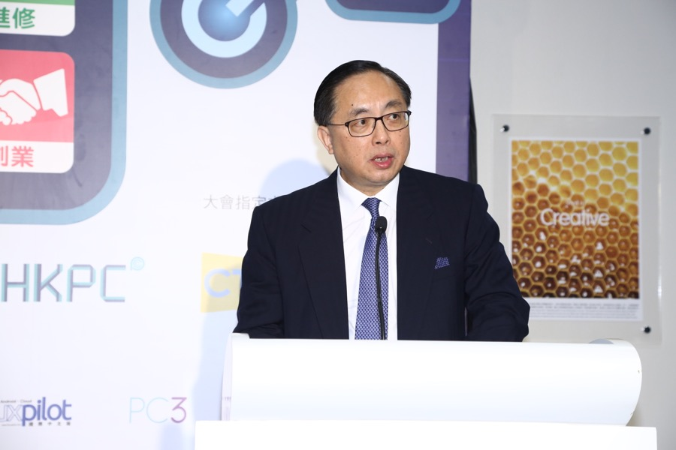

Photo 2:
Speaking at the Hong Kong Computer Society IT Career Expo 2017, Mr. Michael Leung, President of the Hong Kong Computer Society, said HKCS is pleased to see the expo serving as a platform that connects institutions, employers, IT entrepreneurs and IT talent, with an aim of bringing together the wonderful diversity in expertise and creativity of all parties to counter the IT talent shortage.
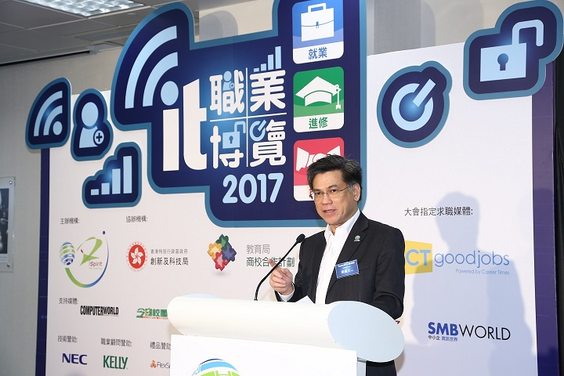
Photo 3:
Mr. Jackie Wong, Chairperson of the Hong Kong Computer Society IT Career Expo Organising Committee, said that the HKCS IT Career Expo is the only such event providing one-stop IT career information with job and continuing study opportunities for the public in Hong Kong, and a series of activities including exhibitions, seminars and sharing sessions focusing on “Employment”, “Start-up” and “Continuing Education”.
Photo 4:
Announcing the results of a survey entitled “IT Industry Employment and Salary Trends”, Dr. Jacky Ting, Assistant Professor, Department of Industrial and Systems Engineering of the Hong Kong Polytechnic University, revealed significant differences in expectations between employers and job seekers on job offerings in regard to the job nature, salary, benefits and working environment.
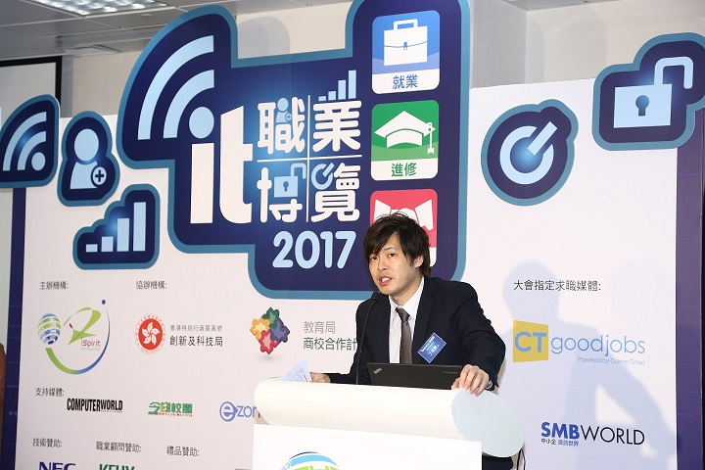
Photo 5:
Mr. Nicholas Yang Wei-hsiung, JP, Secretary for Innovation and Technology, HKSAR Government (fourth left, front roll), Mr. Jackie Wong, Chairperson of the HKCS IT Career Expo 2017 Organising Committee (first left, front roll), and Mr. Michael Leung, President of the Hong Kong Computer Society (middle, front roll), in a group picture with other key attending guests, at the Hong Kong Computer Society IT Career Expo 2017.
Photo 6:
The Hong Kong Computer Society IT Career Expo 2017 provided a wide range of activities including exhibitions, seminars and sharing sessions focusing on “Employment”, “Start-up” and “Continuing Education”, supported by 40+ exhibitors ranging from the banking, technology and telecommunications sectors to academic institutions, and featured over 500 IT-related positions.
